Experiment No :01
Experiment Name: Installing Linus Operating System
Objective:
Linux operating system:
The Linux open source operating system, or Linux OS, is a freely distributable, cross-platform operating system based on Unix that can be installed on PCs, laptops, netbooks, mobile and tablet devices, video game consoles, servers, supercomputers and more.
Different type of Linux distribution:
- Ubuntu.
- Fedora.
- Linux Mint.
- openSUSE.
- PCLinuxOS.
- Debian.
- Mandriva.
- Sabayon/Gentoo.
- Arch Linux... plus Slackware
- Arch Linux... plus Slackware

Ubuntu is the third most popular desktop operating system after Microsoft Windows and Apple Mac OS. It is based on the Debian Linux Distribution, and it is known as its desktop environment.
Linux Installation:
There are two ways of installing Ubuntu OS on your PC.
- CD/DVD
- USB
1.
If you are using a CD/DVD, Restart your computer and Insert your disk.There you will see is an option to ‘BOOT FROM DVD”. Select it and next you will be watching is a ‘WELCOME’ Screen. Now choose your language and begin the installation.
2.
If your are using a USB drive. Press F12 key continuously and then you will get your BOOT options. Select on ‘BOOT FROM USB”. Select it, choose your language and begin the installation.
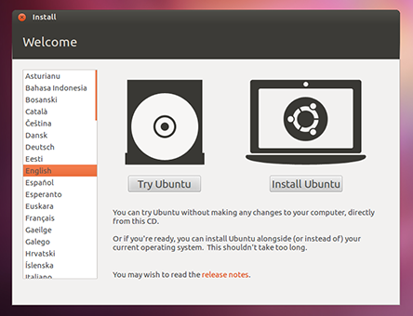

Step#2 The next step is to prepare your PC for installing Ubuntu. It will check that your PC is connected to a POWER SOURCE and you have enough space yo install the OS on your drive.
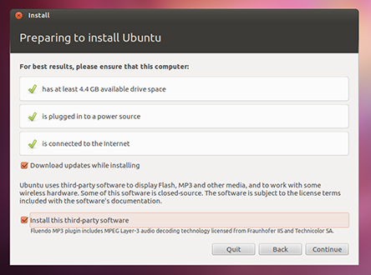

Step#3 While installing the OS there is an option to Download the updates. If you want to download check on it and select your Wi-Fi Connection and give it the WEP key, if you have one.
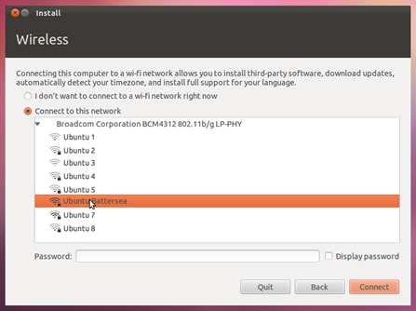

Step#4 Now Allocate the drive to install your OS. If you are a windows user and also have windows installed on your drive, you can use both on your PC but once at a time. If you want to clear the drive and only want to use Ubuntu then select the second option. If you are an Advance User and want to Install it by your own way then select ‘SOMETHING ELSE’.
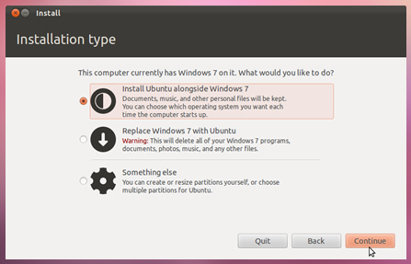Step#5 Ubuntu needs 4.8 GB of space to install. If you have selected the Installation type then click on the drive to install. Don’t worry about installing it along windows.It is easy and simple, also very safe to use. You can uninstall any of the OS at any-time.

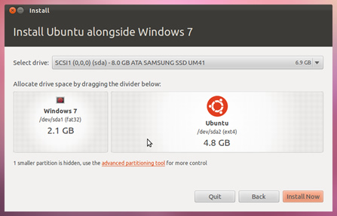

Step#6 Select you location and Proceed to ‘Forward’. If you are connected to Internet, it will auto detect your location. If its wrong then change it.
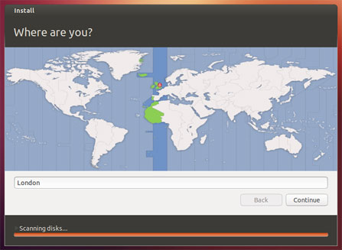

Step#7 Select your ‘Preferred Keyboard Layout’, if you dont know what it means then click on ‘AUTO DETECT’.
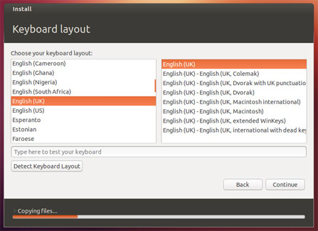Step#8 Now Setup you Login Credentials, it will require your name, Username and Password.
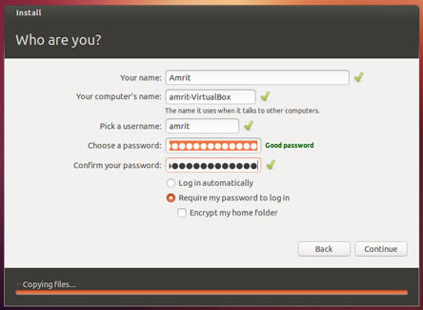

Step#9 While Ubuntu Installs its Important components Grab a cup of coffee and learn more about Using Ubuntu.
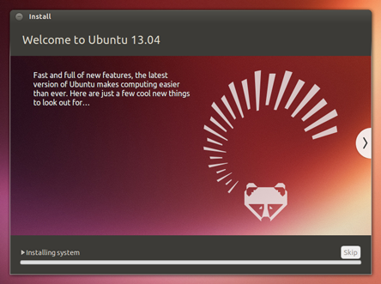Step#10 Congratulations, You have Installed Ubuntu OS on your PC. To get started click on ‘Reboot Now’ and when it gets boot, enjoy your new OS.
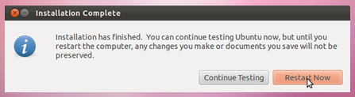
Linux is installed.

Conclusion:
An operating system based on the Linux kernel is called a Distribution or Distro. There are hundreds of Distributions available, some of which are designed to accomplish a sole purpose like running servers, act as network switches, etc. Naming the best Linux Distribution is difficult as they are made for different.

